Assignment 5

Name-Nandini
ROLL NO-2026010075

Q1. Create a class Print with overloaded display() functions to display an integer, a double value, and a string.

#include <iostream>
#include <string>
using namespace std;
class Print {public:
void display(int i) {
cout << i << endl;
}

void display(double v) {
cout << v << endl;
}

void display(string n) {
cout << n << endl;
}};
int main() {
Print p;

p.display(24);
p.display(87.3);
p.display("nandini");

return 0;}
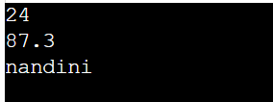

Q2. Create a class Area with overloaded calculate() functions to calculate the area of a square, rectangle, and circle.

#include<iostream>using namespace std;class shapes {
public:
void area(double i){
cout<<"area of square "<<i*i<<endl;
}
void area(float i,float j){
cout<<"area of rectangle "<<i*j<<endl;
}
void area(int r){
cout<<"area of circle "<<(22/7)*r*r<<endl; }};int main(){
shapes a;
a.area(3.0);
a.area(3,8);
a.area(7);}
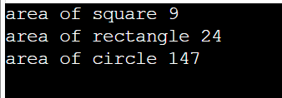

Q3. Calculate Sum Create a class Calculator with overloaded functions named sum(): • sum(int a, int b) — calculate the sum of two integers. • sum(int a, int b, int c) — calculate the sum of three integers. • sum(double a, double b) — calculate the sum of two decimal numbers. Demonstrate all three overloaded functions using an object of the class.

#include<iostream>
using namespace std;
class calculator {
public:
void sum(int a,int b){
cout<<"sum = "<<a+b<<endl;
}
void sum(int a,int b,int c){
cout<<"sum = "<<a+b+c<<endl;
}
void sum(double a,double b){
cout<<"sum = "<<a+b<<endl; }};int main(){
calculator c;
c.sum(3,5);
c.sum(3,8,6);
c.sum(7.0,9.6);
}
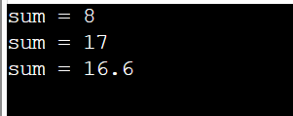

Q4. Create a class with overloaded result() functions to display marks in one subject, calculate the average of two subjects, and calculate the average of three subjects.

#include<iostream>using namespace std;class marks {
public:
void result(float a){
cout<<"marks = "<<a<<endl;
}
void result(float a,float b){
cout<<"average = "<<(a+b)/2<<endl;
}
void result(float a,float b,float c){
cout<<"average = "<<(a+b+c)/3<<endl; }};int main(){
marks m;
m.result(3,5);
m.result(3,8);
m.result(7.0,9.6,10);
}

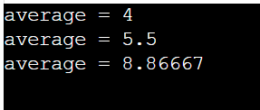

Q5. Find the Maximum (Moderate) Create a class Maximum with overloaded functions named findMax(): • findMax(int a, int b) — find the greater of two integers. • findMax(int a, int b, int c) — find the greatest of three integers. • findMax(double a, double b) — find the greater of two decimal numbers.

#include <iostream>
using namespace std;
class Maximum {
public:
int findMax(int a, int b) {
if (a > b)
return a;
else
return b;}

int findMax(int a, int b, int c) {
if (a > b && a > c)
return a;
else if (b > c)
return b;
else
return c;}

double findMax(double a, double b) {
if (a > b)
return a;
else
return b;}};

int main() {
Maximum obj;
cout << "Maximum of two integers: "
<< obj.findMax(10, 20) << endl;

cout << "Maximum of three integers: "
<< obj.findMax(10, 25, 15) << endl;

cout << "Maximum of two decimal numbers: "
<< obj.findMax(12.5, 15.7) << endl;

return 0;}
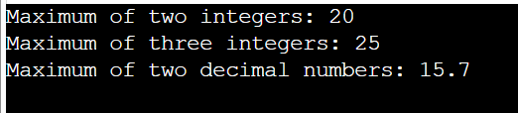

Q6. Shopping Bill Generator Create a class Bill with overloaded functions named calculateBill() to calculate: • The bill for one item using quantity and unit price. • The bill for two items using their quantities and prices. • The bill for a bill amount after applying a discount percentage. Use suitable parameter lists and return the final bill amount.
#include <iostream>
using namespace std;

class Bill {
public:
double calculateBill(int quantity, double price) {
return quantity * price;
}
double calculateBill(int q1, double p1, int q2, double p2) {
return (q1 * p1) + (q2 * p2);
}
double calculateBill(double amount, double discount) {
return amount - (amount * discount / 100);
}
};

int main() {
Bill obj;

cout << "Bill for one item: Rs. "
<< obj.calculateBill(2, 100.0) << endl;

cout << "Bill for two items: Rs. "
<< obj.calculateBill(2, 100.0, 3, 50.0) << endl;

cout << "Bill after discount: Rs. "
<< obj.calculateBill(1000.0, 10.0) << endl;

return 0;
}


